Techniques Used in Renaissance Art

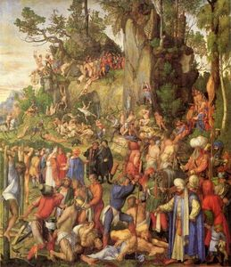Techniques Used in Renaissance Art
During the age of the Renaissance, artists began to depict images with a more realistic goal. The depiction of the human body and objects was not an idealization of the imagination, but rather a means of artistic innovation. While there were many techniques used by the masters of the Renaissance, only the main techniques are described below.

Linear Perspective
- The idea of linear perspective is to create a three-dimensional appearance on a two-dimensional object (e.g. canvas).
- Linear Perspective: http://www.mos.org/sln/Leonardo/ExploringLinearPerspective.html
- http://psych.hanover.edu/krantz/art/linear.html
- Images with Linear Perspective: http://www.google.com/search?q=linear+perspective&hl=en&prmd=imvns&tbm=isch&tbo=u&source=univ&sa=X&ei=wBMzUMq8KYeg8gTQvYHIDg&sqi=2&ved=0CF8QsAQ&biw=1202&bih=642

Sfumato
- 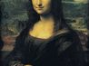
The idea of sfumato was to blend one shade into another in order to create perceptions of depth, form and volume. The most famous example of this technique is the Mona Lisa.

Chiaroscuro
- 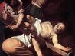
This type of painting uses the contrast of light and dark to create dimension to a painting, which gives the illusion of depth or three-dimensionality. An example of this technique would be works by Michelangelo Merisi da Caravaggio, who developed tenebrism (a form of chiaroscuro where objects appear to emerge from blackness).

Fresco
- 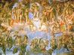
There are two types of frescoes, buon fresco and fresco secco. Buon fresco consisted of mixing pigments with water, and in fresco secco pigments were mixed with binding agents and painted on dry plaster.

Foreshortening
- 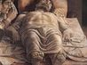
The idea of foreshortening is meant to add depth to a painting by creating the illusion of objects retreating into a background. One artist known for this technique was Andrea Mantegna.

